**Homework 3: Multi-Agent Search**

**Part I. Implementation (5%):**

* 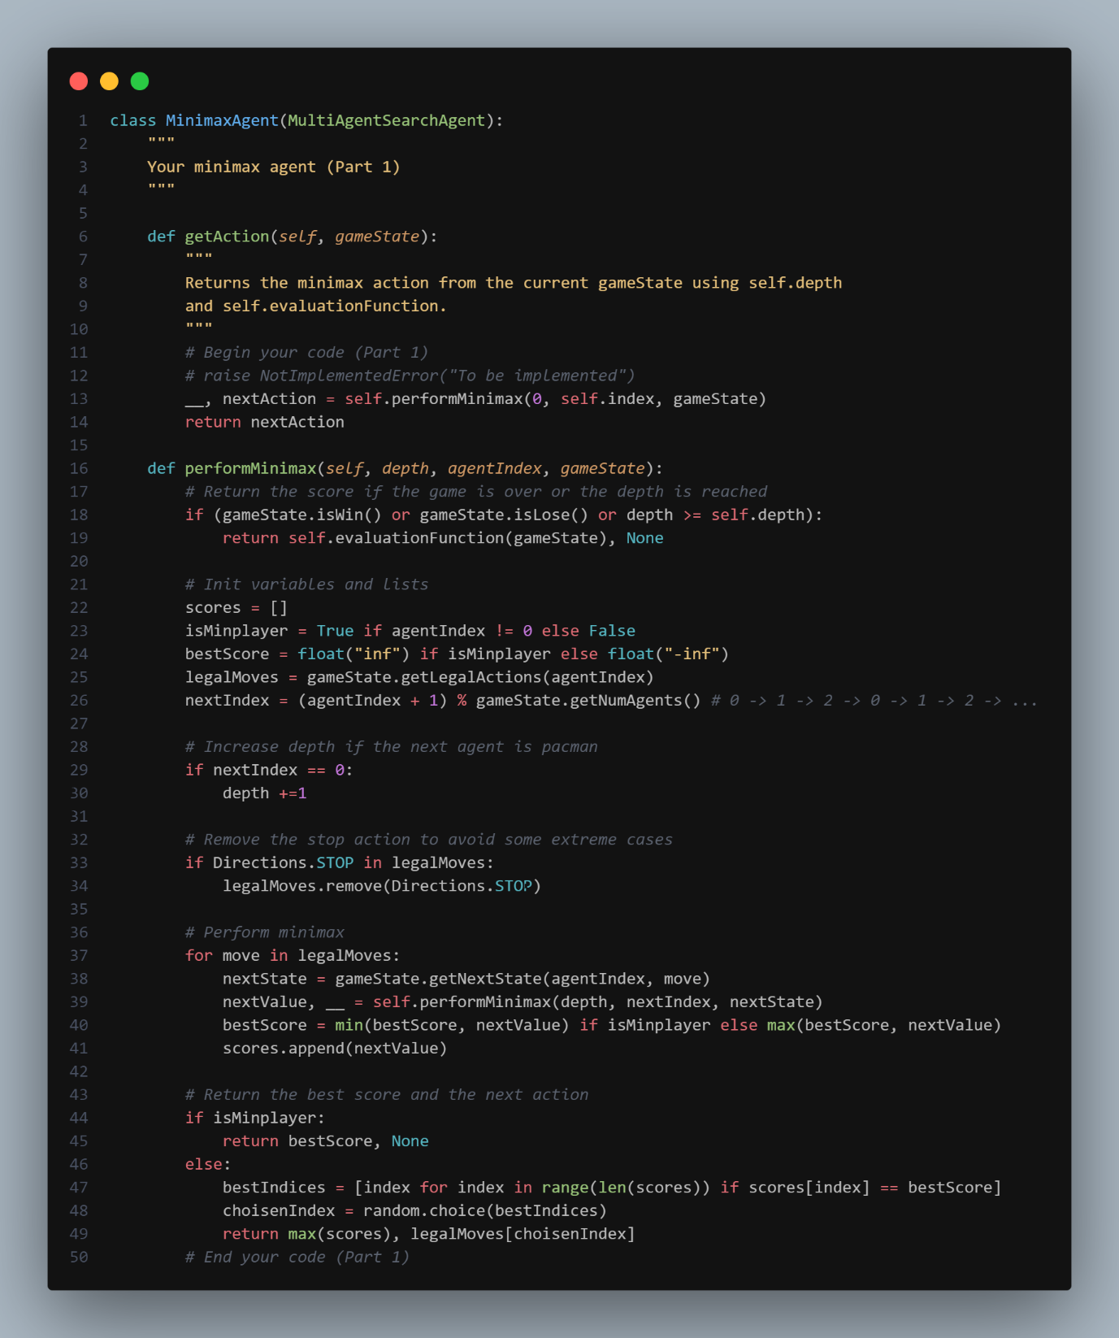**Part 1 MiniMax**
* 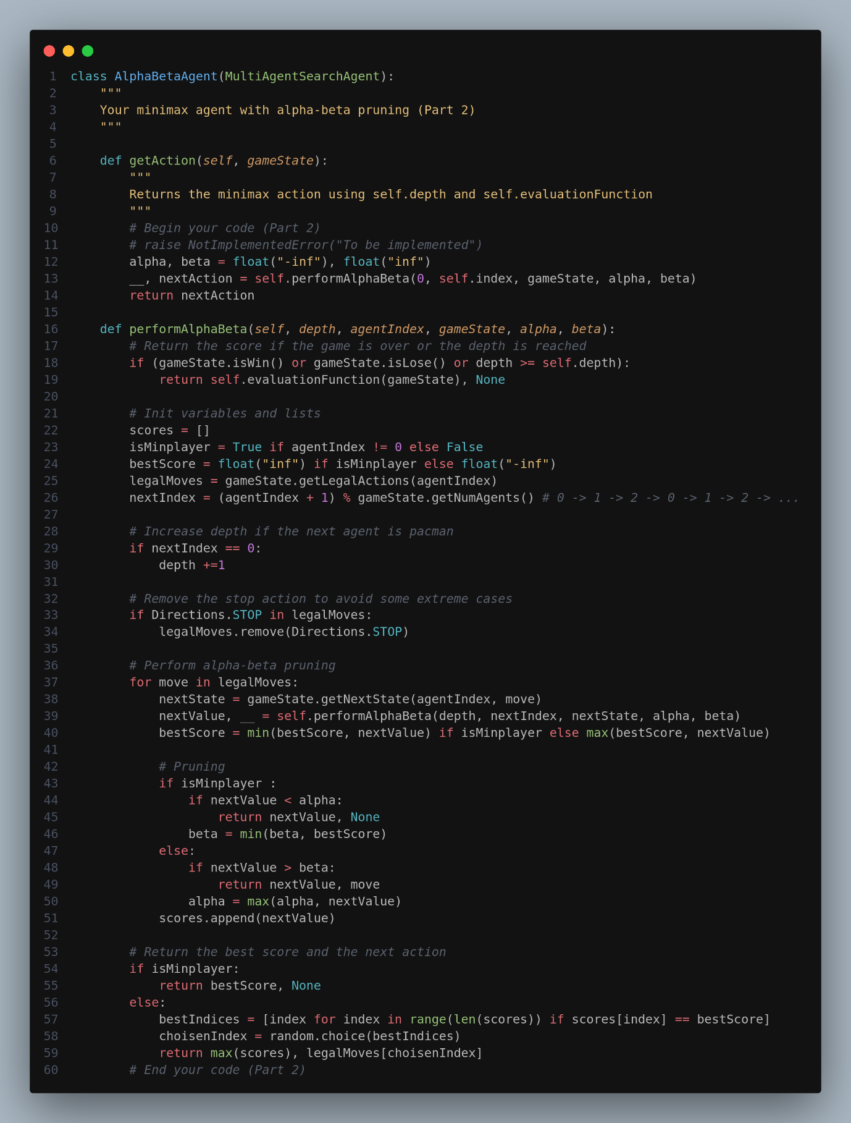**Part 2 Alpha-Beta**
* **Part3 Expectimax**

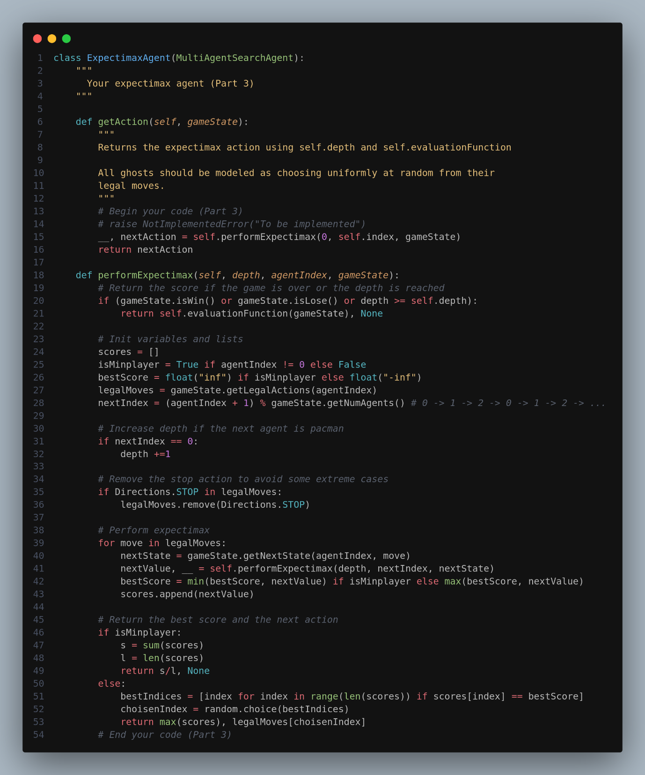

* **Part4 Better evaluation function**

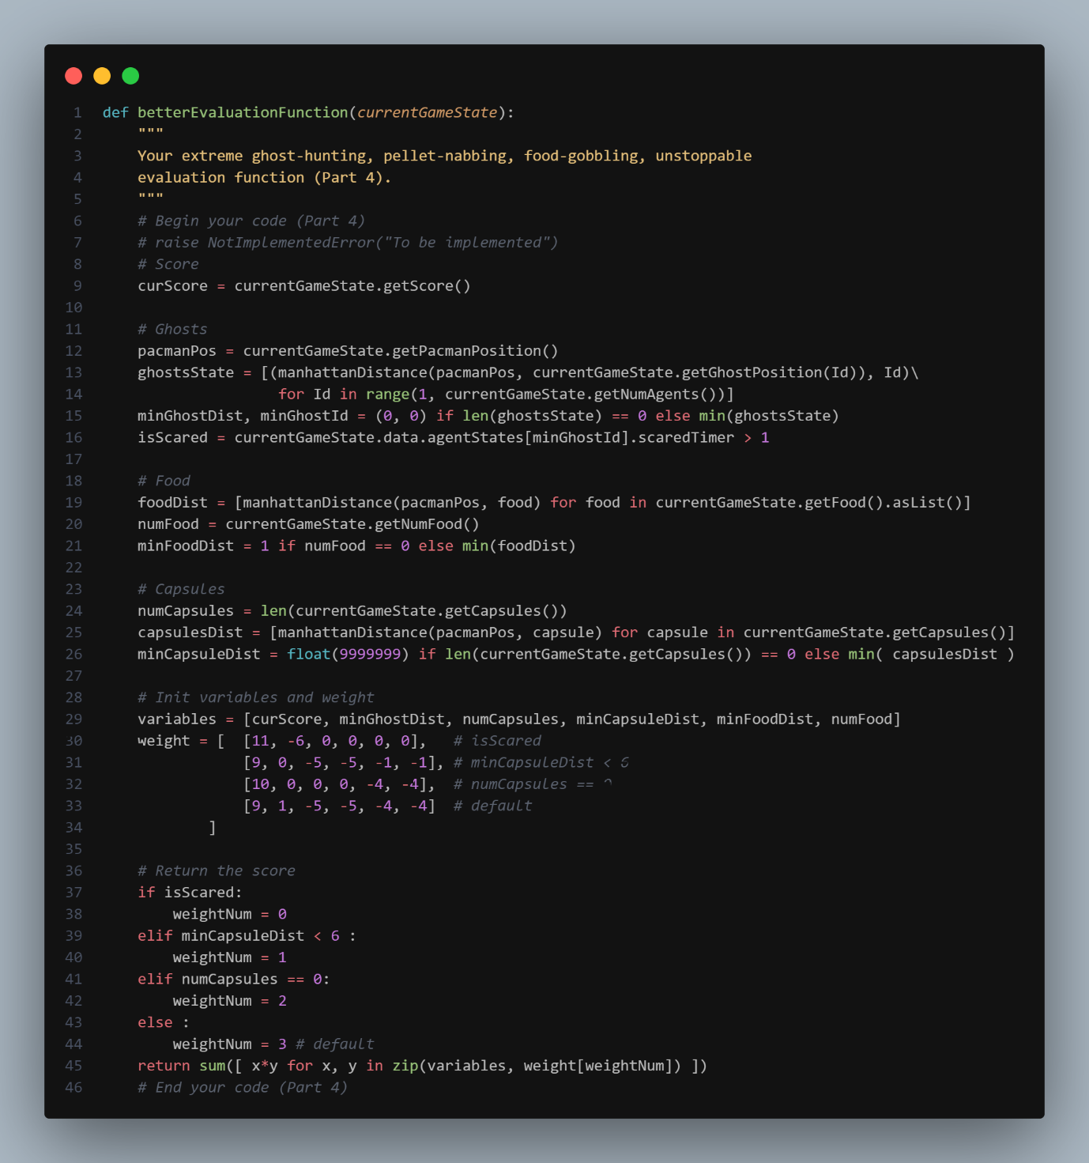

**Part II. Results & Analysis (5%):**

* **一張含有 文字 的圖片

  自動產生的描述The screen shot of the result.**
* **Analysis**
* **The main goal of this evaluation function is to achieve the highest possible score. Therefore, Pac-Man is designed to chase the target with the highest score, which includes scared ghosts, capsules, and food in a priority sequence from strong to weak. By applying a negative parameter to the number of prey and adding it to the evaluation function's return score, Pac-Man will be more likely to chase the target. The reason for this is that if the number of preys decrease after Pac-Man's move, the negative parameter will result in a higher return score, making the move more likely to be chosen.**
* **If there are any scared ghosts, Pac-Man will desperately chase them while avoiding unscared ghosts. In the absence of scared ghosts, Pac-Man will continue eating dots, but if a capsule appears within six units of distance, Pac-Man will switch to eating the capsule. If there are no capsules left, Pac-Man will focus on eating dots.**
* **In a previous version, Pac-Man had a main problem of repeatedly turning right and left near the capsule, waiting for the ghost to come close enough to eat the capsule. This problem led to a lower score due to the time wasted waiting for the ghost. After debugging the if-else condition, I realized that the evaluation function evaluated the move's result, and the condition used had not yet occurred.**
* **The main reason for this problem was that the evaluation function told Pac-Man that the ghost was scared, which would happen after Pac-Man made the move. This caused Pac-Man to switch targets to the ghost. After the Pac-Man left for a small distance, the evaluation function returned a value indicating that there were capsules within six units of distance, causing Pac-Man to switch back to the capsule again. I fixed the bug by increasing the score under the condition of any capsule being closer than six units of distance. This make Pac-Man choose to eat the capsule rather than chase for the ghost before the capsule is eaten.**
* **The Pac-Man turn repeatedly.**

